Barking Mad Dog Rescue

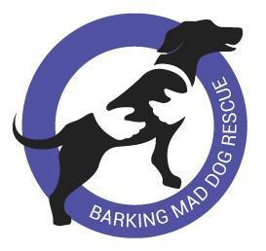
Volunteer Application Form 2025

Thank you for your interest in our dogs and our work in Romania. We are so grateful to our wonderful volunteer teams, without whom, we would not function. We are delighted that you have shown interest in volunteering for BMDR.

Please download this form and complete it as fully as you can. Then email it to info@barkingmaddogrescue.co.uk.

Your Details
Date:
Name:

Are you a Facebook member?

Do you use WhatsApp?

How is it best to contact you?

Skillset and Experience
Is there a specific role you would like to volunteer for in BMDR?

Some examples of roles are:
- helping with social media
- helping with fundraising and raffles
- helping with our auctions
- joining our adoptions team,

There are also lots of other activities to suit a range of skills. You might have ideas of what you can bring.

Please note we match volunteer skills and experience to our available roles in the team. We can’t guarantee that we will be able to offer you an exact match for your preferences.
What relevant skills, knowledge, and experience do you have that you could bring to a volunteering role?

**Please give as much specific detail as possible

Have you had any previous volunteering experience in any capacity (not specifically animal rescue)?

If so, please give details:

Do you have any experience with rescue dogs, specifically?

If so, please give details:

What do you hope to get from your volunteer role?

How much time do you feel you can give to volunteering with BMDR?

(e.g., one hour per week, only time on weekends, time every day, etc.)

Is there any additional information you would like us to be aware of?

Do you have any questions you would like to ask us?

Thank you. It can take us a few days to get back but we definitely will.

